The Lost Ship Chapter 1: Jak's Hidden Threat

The Colossal Throne Room
The massive doors groan shut behind you with the finality of a tomb sealing. You stand in a vast chamber that seems to swallow sound itself - your footsteps echo and die in the oppressive darkness above. Towering walls of raw, unadorned stone rise into shadow, their surfaces scarred and pitted as if carved by some titanic force in ages past.
Floating orbs of pale, cold light drift through the air like lost souls, casting shifting shadows that dance across the brutal architecture. They seem to sense your presence, drifting closer to illuminate your path toward the far end of the chamber.
There, upon a throne hewn from a single block of black stone, sits Jak. The throne itself is a monument to excess - twenty feet tall, its back carved with angular reliefs that hurt to look at directly. The entity that rules this place appears smaller than usual, almost diminished by the sheer scale of his seat of power.
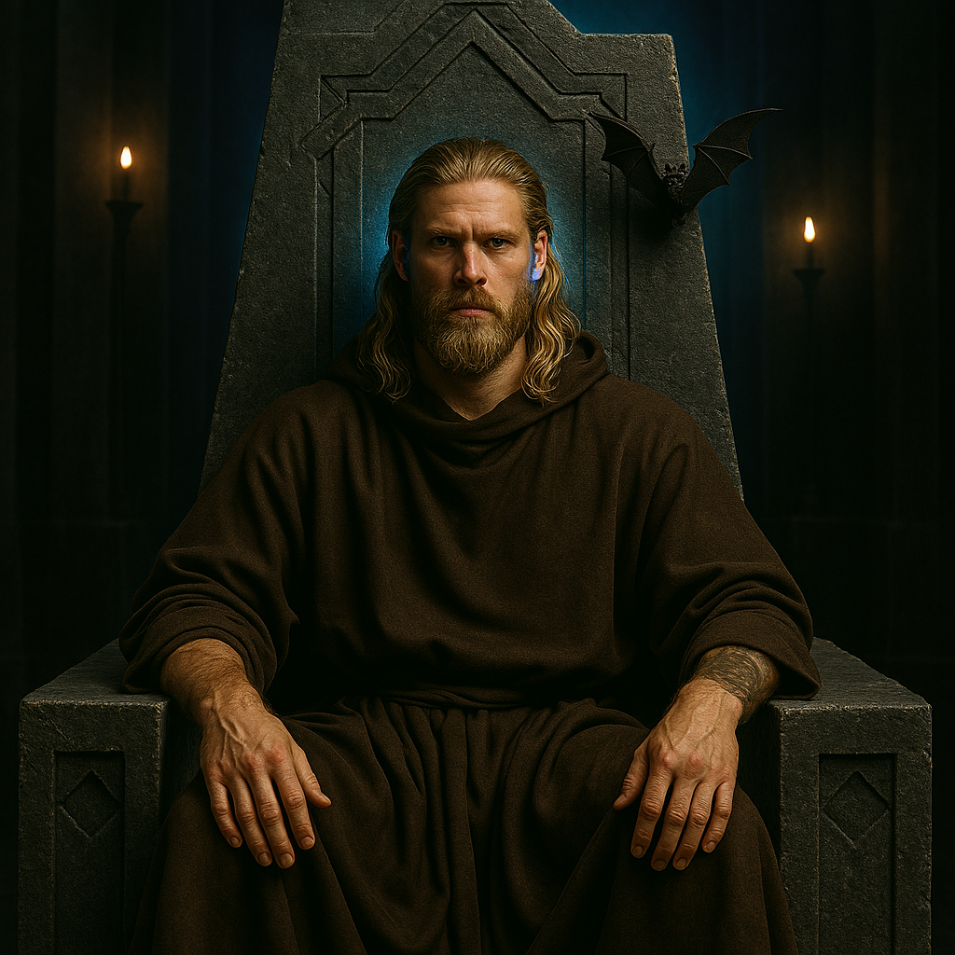
His dis-trans bat glings to the throne's massive back like a living shadows, It’s agitation palpable even from this distance.

Jak's Revelation
Jak: His voice echoes strangely in the vast space, carrying undertones of barely controlled fear
"Approach, my wayward friends. The orbs will guide you safely - they know not to lead the worthy astray."
As you draw closer, you can see his hands gripping the throne's armrests, knuckles white with tension. Behind his left ear, the familiar blue glow of his Aura implant pulses
"Something beyond the reach of the vermoon-world-network plagues the southern peaks. My scouts return to me... changed. Terrified. They speak of an unthinkable darkness A VOID."
The dis-trans bat spirals down to perch on his shoulder, chittering frantically
"This one was my best reconnaissance unit. See how it trembles? It found the source of the strange creatures terrorizing the southern lands. glaciers, but when it approached that place..."
His voice drops to a whisper that somehow carries perfectly across the stone
"Nothing. Complete void. As if that place doesn't exist in our reality at all."
He stands from his throne, the weight of absolute authority making the gesture more imposing despite his obvious distress
"My friends - and you ARE still my friends, despite all this-" he gestures at the throne room "you know what I was before the implant. A simple monk. A wanderer, like you. But now, through Aura, I oversee every corner of the known world. Every settlement, every trade route, every living soul connects through the network."
His form seems to flicker as the implant pulses more rapidly
"But there is something in those southern peaks that exists as a void. A hole torn in the fabric of reality itself! Strange creatures emerge from this... absence... creatures that shouldn't exist, that follow no natural patterns."
He leans forward, his voice taking on an urgent, almost pleading tone
"No scrying can penetrate it. No ancient magic can divine its nature. Even the oldest powers that predate the network cannot touch whatever lies within that void. The local clerics have preserved corpses of the creatures in brine, but even their wisest sages cannot identify these... things. And I - Administrator of the known world - am utterly blind to what festers in that hole in our reality!"
He steps down from the throne, approaching you with the familiarity of old companionship, yet the authority never leaves his bearing
"Don't you see? This is why we traveled together years ago, my friends. Why fate brought us to that first cursed vessel above the clouds, why you defeated its Administrator. It was preparation - training for what lies ahead in that... that absence in the world."
The dis-trans bats swirl in increasingly agitated patterns around the floating orbs
"Will you venture into that void where nothing can see? Will you be my eyes and ears in the one place that exists outside reality itself? I... I need people I can trust absolutely. And despite the crown that weighs upon my head, you are still the only ones I trust with this."

The Mission
The characters must investigate the source of these strange creatures and determine:
- What exactly is causing the monsters to emerge from this void
- Who or what is responsible
- How to prevent future incursions
- Any other information about this mysterious absence in reality
The void in the southern Barrier Peaks awaits, along with whatever otherworldly secrets lie beyond this hole in the fabric of the world.

